Raye Green talks
Agatha Christie and North Somerset
Only Connect
Raye Green
27th February, 2023

A look at five connections between Agatha Christie and North Somerset – one of which, amazingly, features Worle.

Only Connect …………Agatha Christie and North Somerset
During the years of the pandemic I have come to realise that I am one of those folk who looks for connections everywhere … particularly between people and the places they inhabit. I am often on the lookout for a new project and I especially love detective work. Outside of my family and friends, my passions are Worle, a village in Somerset where I grew up and still live, and Agatha Christie, whose works I have been reading since I was a child. There are other things, of course, but these two are principal preoccupations.
Amazingly, and however tenuous, I have found some links.
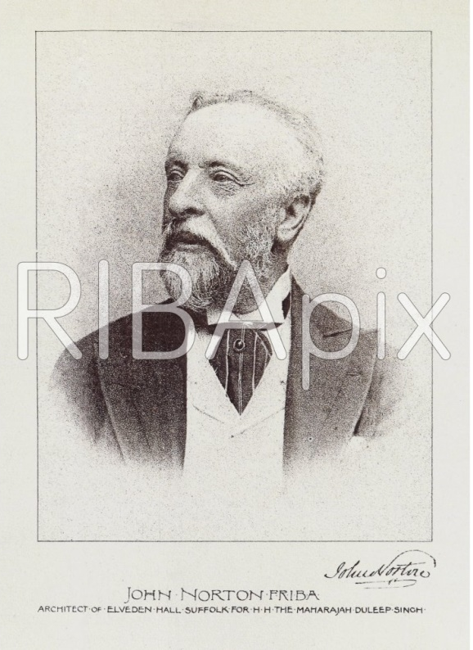
I begin with an architect who was plying his trade during the reign of Queen Victoria. His name was John Norton [1823 to 1904]. This picture of the gentleman was found at the RIBA website and purchased for the princely sum of £23. As I write I am awaiting the delivery of the pic without the watermark. Norton, John (1823–1904), architect, was born on 28 September 1823 at Bristol, the son of John Norton and his wife, Sarah, née Russell.
In 1846, after attending Bristol Grammar School, he became a pupil in the London office of Benjamin Ferrey. It was there that he developed his love of Gothic Revival style which is evident in the four buildings he worked on locally. He married at Clutton, Somerset and had a large family, so its just as well that he left £3,596 – quite a fortune in 1904.
So let’s look at how this talented chap has given Worle and North Somerset a link with Agatha Christie.
In the early 1860s Norton was a very busy architect in his 40s – slightly past his prime by Victorian standards. He was working simultaneously on at least 4 projects: the massive re-design and refurbishment of Tyntsfield House near Wraxall; the new building of Emmanuel Church in Clifton, Bristol; the re-design of the old Monastic Barn in Worle to provide Worle with a new site for the National School with more space and better facilities and finally the redesign and refurbishment of St Martin’s Church, Worle.
Firstly, we need to look at the building of a new Church for people of a ‘low Church’ disposition. The Church became known as Emmanuel Church, Clifton, Bristol. John Norton was the architect. His original design for the building included a tower surmounted by an elegant spire. The spire was never included in the final building. This picture, from The Builder, is dated 1872, some years after the building was completed. It is featured at the following link: http://www.churchcrawler.co.uk/bristol3/clifemm.htm. The final design only featured the tower and had less ornamental small spires around the top.
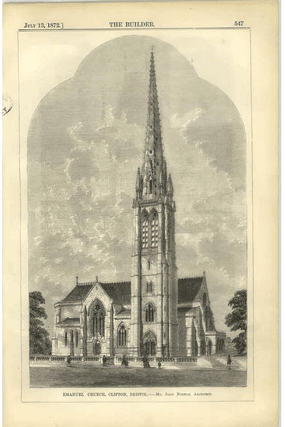

The site of Emmanuel Church is adjacent to the playing fields of Clifton College, where, in Edwardian times, Archibald Christie was a pupil. Two of the teachers at the school during Archie’s time there were his step-father and one Major Belcher. These connections may explain why, on the 24th December 1914, almost 50 years after the Church was built, Archibald Christie chose this venue to marry Agatha Miller by special license. Archie’s family lived in Bristol and were present at the ceremony. It was at the altar, pictured below, that Agatha Mary Clarissa Miller became Mrs Christie. Archie’s step father, William Hemsley, was one of the witnesses. The first link, of which I’m sure Agatha was quite unaware, was established between her and John Norton, the man who designed the building where her famous name was born.
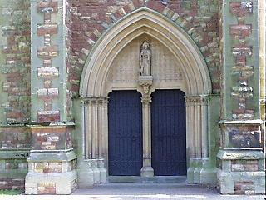
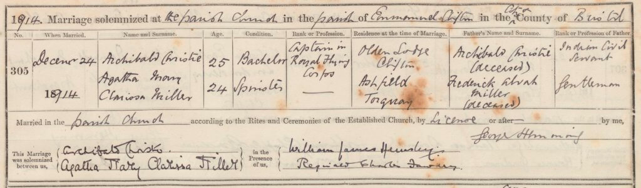
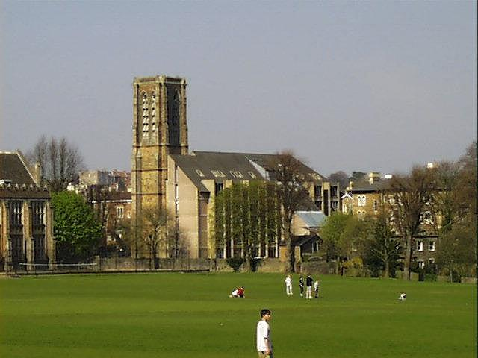
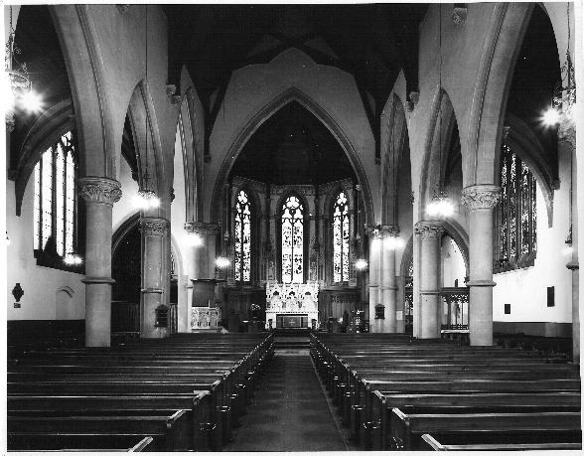
One of the teachers at Clifton College whilst Archie Christie was a pupil was Major Ernest R. Belcher, who will be involved in another AC connection.
Much of the original church building was demolished in the 1970s and replaced by bespoke accommodation for people who need supported living.
Only the square tower remains standing and is used as a storage area when I visited it in 2019.
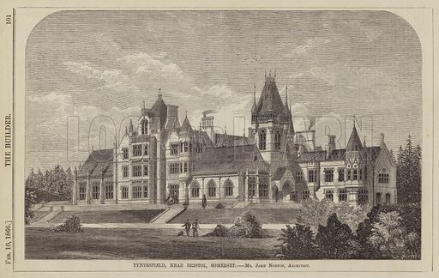
The second connection. Tyntsfield House, or at least its interior, was used to film Agatha Christie’s Crooked House. This is a ‘must do’ visit for any Agatha location fans as well as historic grade 1 listed buildings enthusiasts. Watch the film before you pay it a visit.
A drawing of Tyntsfield house as John Norton envisaged it
The outside shots in the film [2017] were taken elsewhere. Perhaps Tyntsfield was too madly Gothic. https://www.youtube.com/watch?v=oN7OHj_vbPc The link will take you to the official trailer for the film.
So, the links between Agatha Christie and John Norton were consolidated 150 years after the building of Emmanuel Church, when some insightful director chose the interior of Tyntsfield House to represent scenes from one of Agatha Christie’s favourite books, Crooked House. This book did not include any of her usual sleuths and has a plot and an ending which demands the Gothic Revival style of our architect, John Norton. The drawing shows Norton’s vision. The result in the 21st century is featured below:
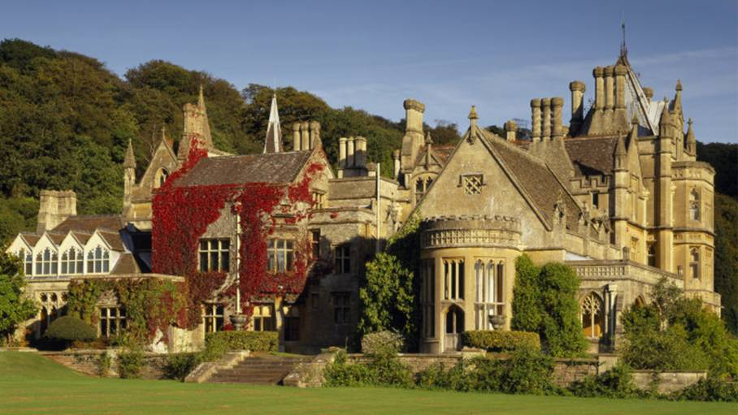

Now for a third connection. Concurrently with work in Clifton and at Tyntsfield, John Norton was working on the drawings for Worle National School, on the site adjacent to St. Martin’s Church. It was for all children from 5 years to 12 years of age and remained so until 1901 when it became Worle Junior School. Now it is Worle Village Primary.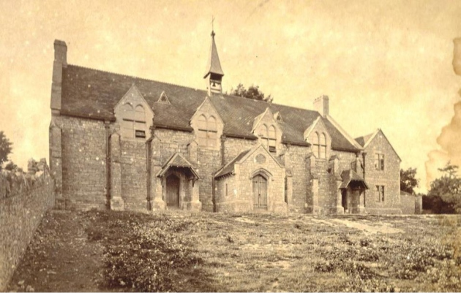
This project was not on the scale of Tyntsfield House, but it took some imagination and courage. It was based on the remains of a Monastic Barn. The picture above shows the south facing elevation of the finished renovation. Below is a drawing which tells us what John Norton had to work with. It is dated 1843, about 20 years before Norton worked on his ideas for the new school. The 4 walls and 8 buttresses were incorporated in the newly constructed schoolrooms.
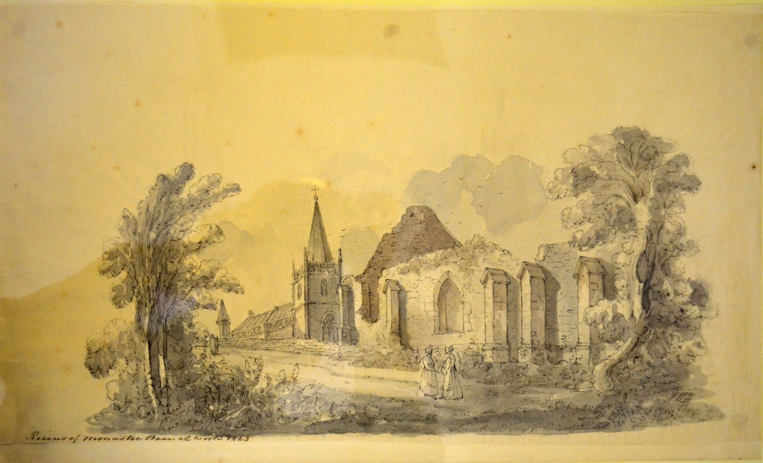
This school provides us with the link between John Norton, architect, and Agatha Christie, novelist. Tenuous it may be, but it is there. The ‘new’ premises for Worle National School was inaugurated in November 1865 and is still a school in 2020. The renovation was completed for the sum of £850. In 2019, a blue plaque to mark the history of the old school was unveiled. I was a pupil at this school from 1953 to 1957, when it had become Worle Junior School and during this time I read my first Christie novel: The Body in the Library.
The fourth connection with John Norton and Worle in the county of Somerset.
With the approach of the 1870s the Church of St. Martins, Worle, situated close by the new National School in the old Monastic Barn was deemed to be in need of a Victorian make over. John Norton was again selected as the architect for this project. Rev. Nathaniel Woodhouse M.A. had been vicar of Worle since 1829 and the changes to the church building was his brain child. The following cuttings from the period provide us with a much needed description of the interior of St. Martins as well as the events leading up to the work.
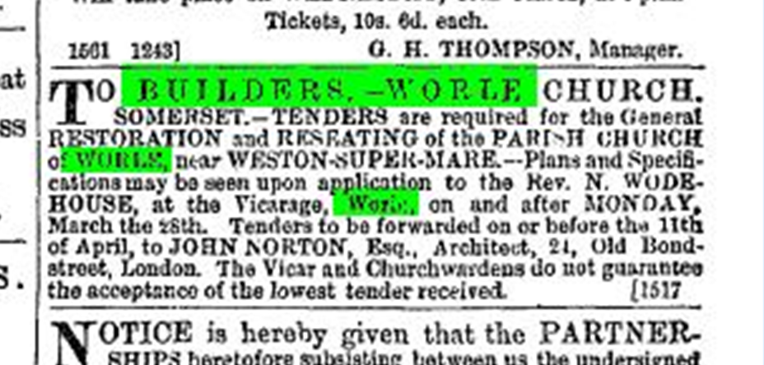
I understand that the tender accepted to carry out the building work was given to James Diment, of 10 St James’s Square, Bristol. https://www.jstor.org/stable/41613603?seq=1 This link will lead to some further information about this firm, but further research may be advisable.
We do know that in October 1870 Rev. Woodhouse died, so he did not live to see the reopening of St. Martins. The text chosen by Rev. Stephenson for the afternoon service may have been chosen in his memory. It reads:
“Quenched the violence of fire, escaped the edge of the sword, out of weakness were made strong, waxed valiant in fight, turned to flight the armies of the aliens.”

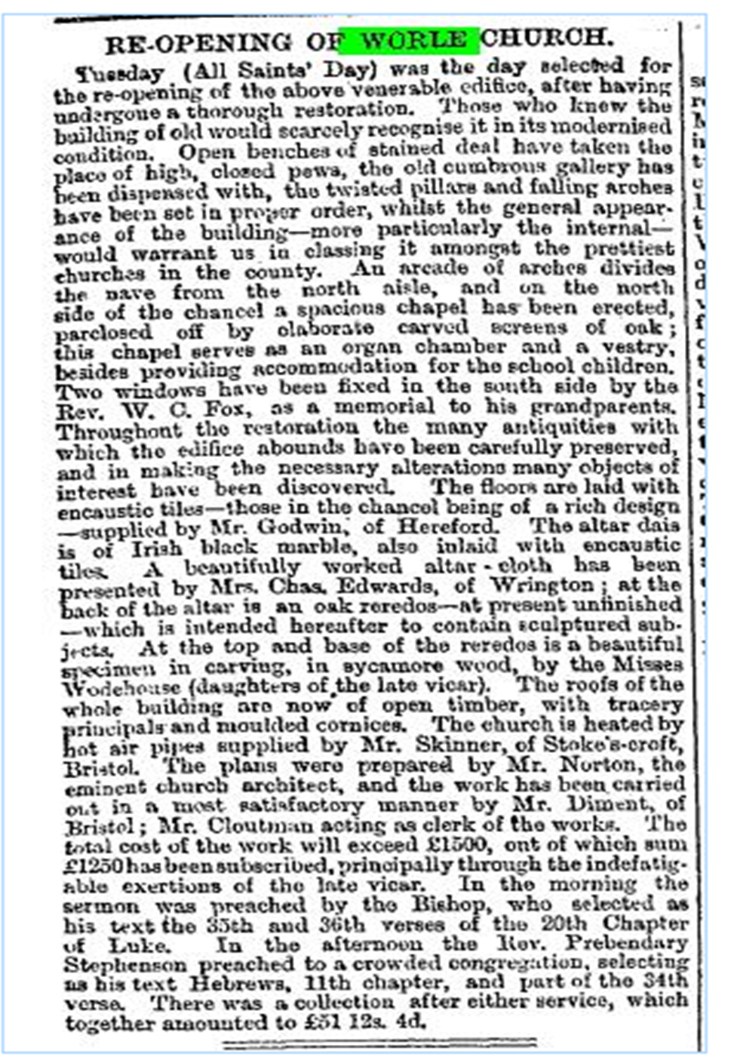
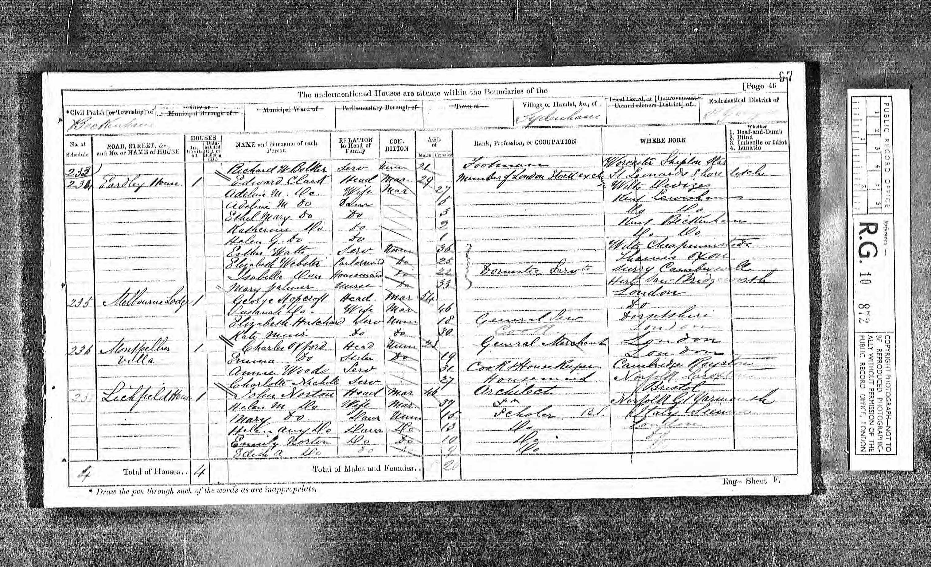
In the 1871 census, we find Norton and his family living in Lichfield House, Sydenham. Maybe his close connections with North Somerset were over. We know that he died at the age of 82.
So much for the John Norton links to Agatha Christie. What more can we find?
1922 is the next interesting date. Agatha and Archie Christie had been married for eight years and had a daughter, Rosalind, who was born in 1919. Archie was invited to take part in a tour of the British Empire’s major member countries as finance director for the tour. The idea was to publicise the coming British Empire Exhibition which was to be staged at Wembley Park and was the brain child of Major E. A. Belcher who had met Archie Christie at Clifton College. Archie was keen for Agatha to join him on what was to be pretty much a World Tour lasting 10 months. A book about the tour has been published: Agatha Christie, The Grand Tour. It is based on letters and pictures sent home by Agatha to her mother and other family members, who were looking after Rosalind in her parents’ absence. The book is edited by Mathew Prichard, who is Rosalind’s son and Agatha’s grandson.
The tour included visits to South Africa, Australia, New Zealand, Honolulu and Canada, which must have given the young author a vast array of ideas and experiences to draw upon. At this time Agatha’s first novel, The Mysterious Affair at Styles had been published and was followed by The Secret Adversary.
The tour party left London in January 1922, and coincided with the publication of The Secret Adversary. Their departure was photographed for The Times, but they managed to get the names in the wrong order. Agatha is actually 2nd from the right!
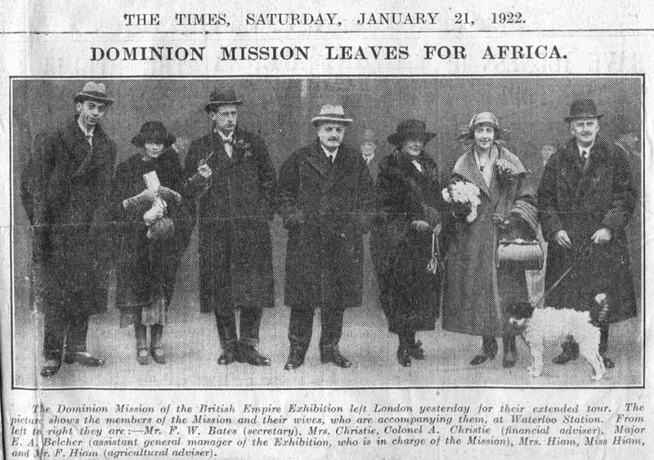

There can be no doubt that Agatha Christie loved a good mystery, and one minor one is about to unfold. One would assume that having gone to such lengths to publicise the “Colonial Exhibition”, Archie and Agatha would have been present at the grand opening by George 5th on 23 April 1924. Oddly there is no mention in any of the autobiographical writing of Christie herself [she often omitted bits and pieces] and neither is the Opening Ceremony cited in any of the biographies. Even scouring the film footage of the opening, frame by frame, does not place Agatha or Archie at the scene. It may be that they had had enough of the company of Belcher and Co., their fellow travellers, but the chance to see the King, Queen, Prince of Wales etc. should have overcome that. Also, it is not the sort of event that slips one’s mind when writing about life.
Perhaps we must reluctantly assume that they did not go. After all Agatha Christie was not a celebrity in 1924. She had published a small number of books: The Mysterious Affair at Styles [1920], The Secret Adversary [1922], Murder on the Links [1923], and then Poirot Investigates [a selection of short stories that came out in March 1924]. Undoubtedly she was very busy at this time, but the Christies may not have been on the invitation list.
However, with or without Agatha, the people of the village of Worle in Somerset, many of whom had attended Norton’s school on the hill, heard the speeches of George V and others, and I dare say the same was true at other venues across the country, so perhaps the Christies just listened with the masses.
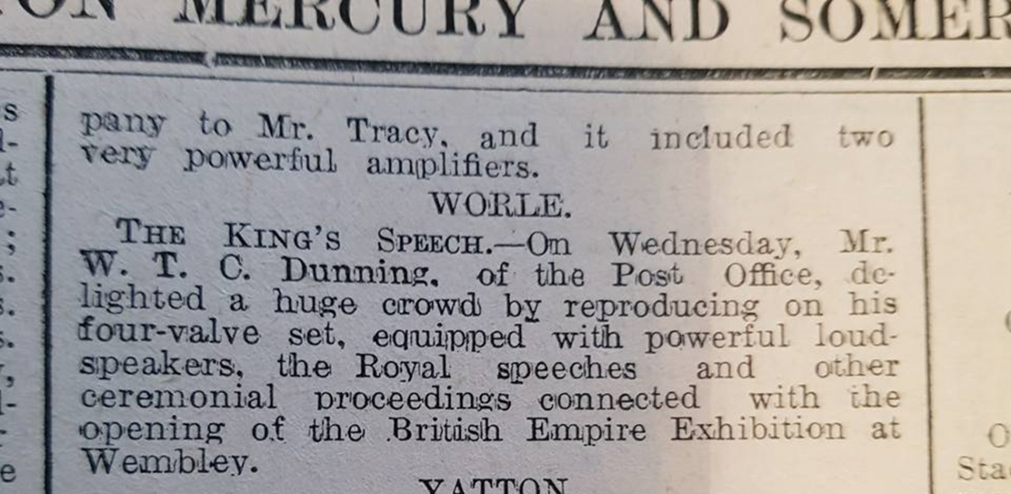
How did the people of Worle manage to listen to the Monarchical voice? It was all thanks to Mr. Dunning [senior] postmaster at number 2 The Parade in Worle High Street. He must have possessed a wireless receiver. The good chap set up a loud speaker system of some magnitude outside the shop, so right opposite the War Memorial and on St. George’s Day 1924 the village gathered and heard, quite clearly the voice of King George 5th

The sub-headline, ‘The King’s Speech’ has since been immortalised in an award winning film. Different King; different speech!!
The cutting gives us the proof of a tiny link between Agatha Christie and our Somerset village. The Post Office in question is featured in the picture below.
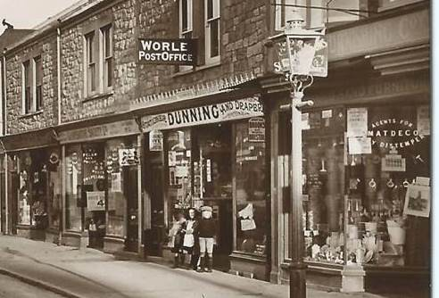

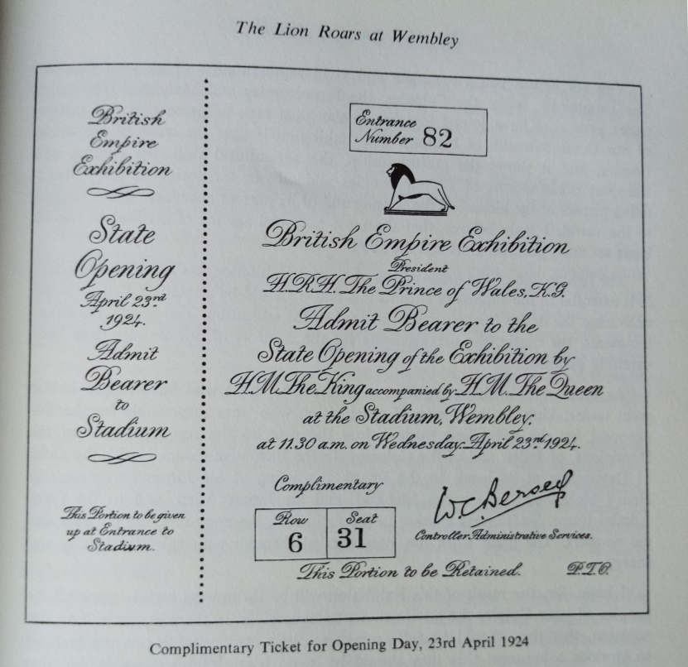
So who was invited to the grand opening of the exhibition? Presumably all the major organizers, at least. The six men who featured in the official programme were His Grace The Duke of Devonshire, Sir James Stevenson, Lt Gen. Sir Travers Clarke, Sir James Allen, Sir Charles McLeod, Lt Col Sir A. Henry McMahon. No mention is made of Major Ernest Belcher or of the Christies, or indeed of the Grand Tour.
The complimentary ticket certainly suggests that a considerable number of people were given free admission to the opening ceremony.
A year later, Agatha Christie’s involvement with the British Empire Exhibition was revived. It was decided, following public demand, to offer another 6 months of the exhibition in 1925, but the organisers needed to come up with some new attractions.
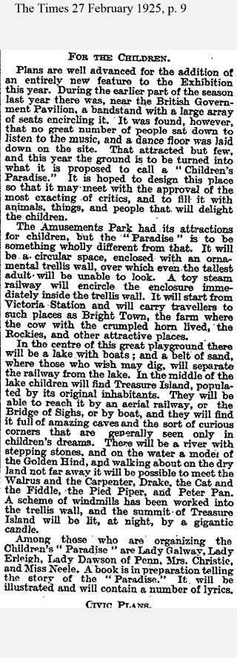
Maybe the Duke of Devonshire was still in charge, but I have found no indication of who chose the women who sat on the committee. Yes, women. The word ‘children’ had been mentioned!! It does seem likely, however, that Major Belcher has some influence over the choices. Mrs Agatha Christie was one person chosen to sit on the committee to design the new Treasure Island attraction for children. Her name appears in the cutting on the following page, but is seldom referred to buy AC buffs and certainly not by Agatha’s descendants and so forth.
Why is it ignored? Because of the list of people who worked with Agatha on the committee: Lady Galway, Lady Erleigh, Lady Dawson of Penn, Mrs Christie and Miss Neele!
It is the final name that creates the difficulty.
Miss Nancy Neele was known to Belcher, but was not his secretary as has been claimed by some AC buffs. In Laura Thompson’s Agatha Christie, An English Mystery on page 173 Thompson quotes Archie Christie as saying: “You know that dark girl who used to be Belcher’s secretary?.....”
In her end notes Thompson says that Nancy Neele was never secretary to Major Belcher, but she worked for the Imperial Continental Gas Association. Belcher’s secretary on the tour was Francis Bates, note the male spelling.
Nancy was well acquainted with Belcher, however, and was a keen golfer, as was Archibald Christie. They spent a great deal of time together on the golf course. Nothing is known about how their relationship developed, and even less is known about how Mrs Christie and Miss Neele managed to work together on the committee, but it does suggest that Belcher, friend or not, might have been unwittingly responsible for the Christie’s marital troubles. Possibly, Belcher was aware of the relationship between Archie and Nancy for some time before it came to Agatha’s notice.
Is it safe to say that Agatha Christie was blissfully unaware of any troubles in 1924, when The Man in the Brown Suit was published? In fact, it is likely that the affair began later than this. Had she had any suspicion that Archie was straying and that Belcher had knowledge of it, she would not have dedicated the book to Belcher.
I have a vision of Agatha and Nancy being rather pleased to be invited to assist with the planning of ‘the new attraction’, and being quite unaware of the irony of the term.
So it is possible, a hundred years on, to reflect on all these happenings and draw some conclusions which may or may not be accurate. The connections with North Somerset and Worle, via an architect, two churches, a radio broadcast, a wedding and a grade 1 listed building, a film set and two schools have been overtaken, in Christiesque style, by a mystery. Fancy that!

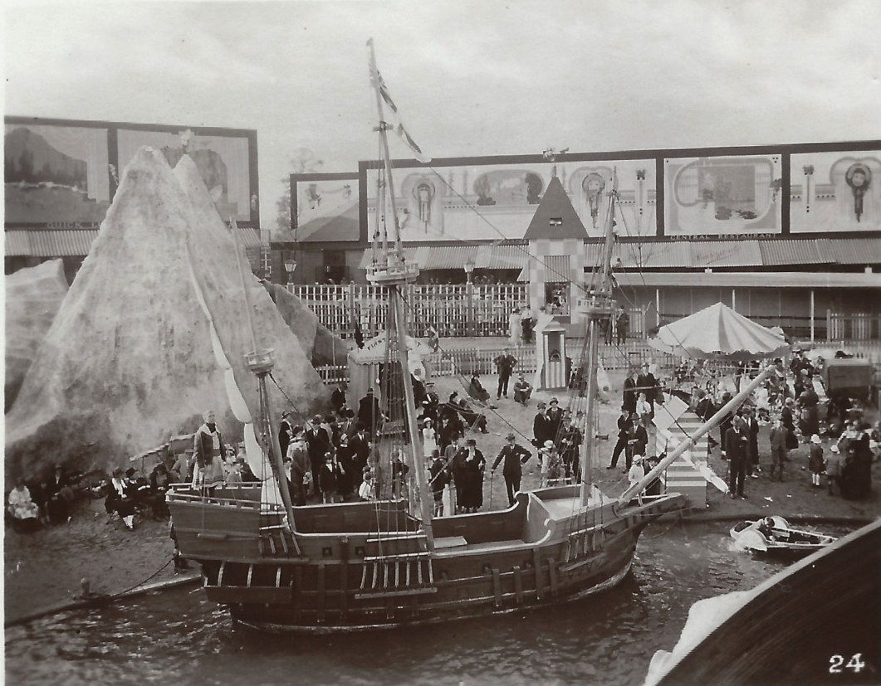
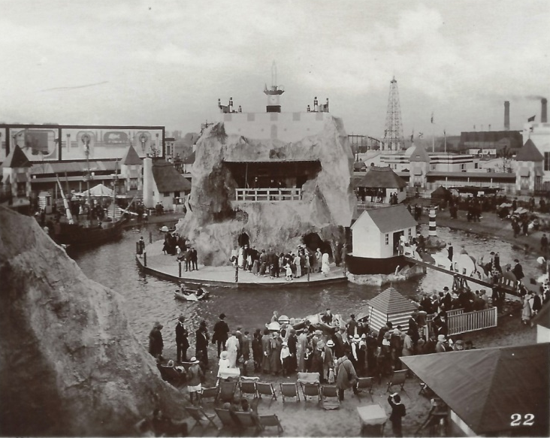
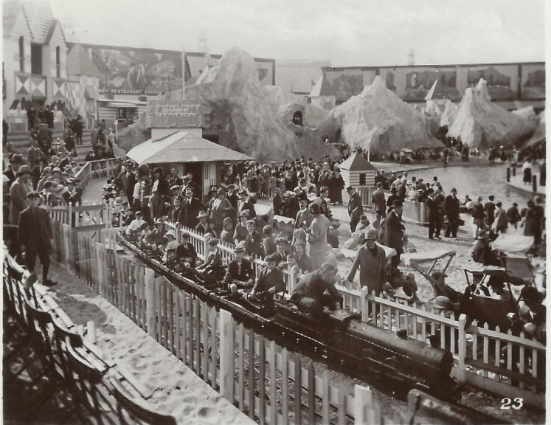
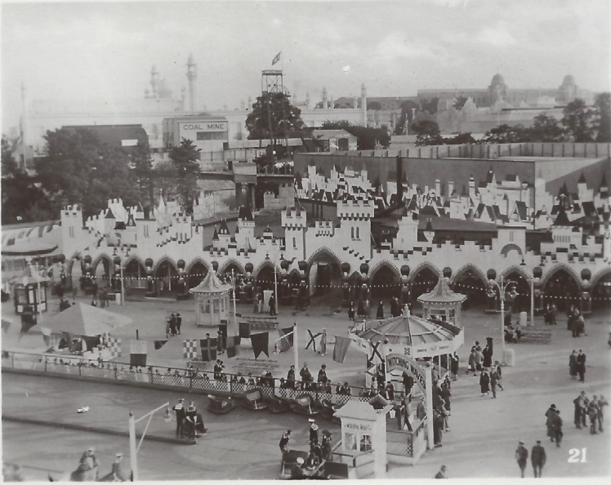
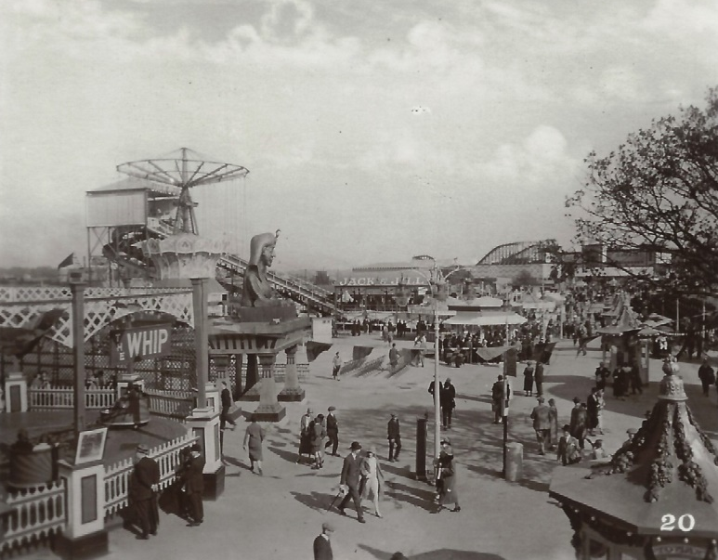

Appendices
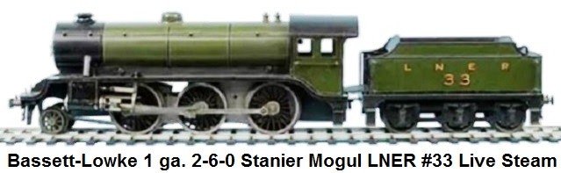
Bassett-Lowke & Co. In 1924 the smallest railway in the world was made for the Queen's Doll House; also several special ocean liners and a 2½" gauge model of Canadian Pacific styling were produced. In 1925, a 7¼" gauge passenger-carrying railway was built for the Wembley Exhibition, and called Treasure Island Railway. The late King George V and Queen Mary enjoyed a ride on this train. A 1¼" scale model of a Southern Railway King Arthur class locomotive was built for Sir Berkley Sheffield. A green gauge 1 steam-powered version of the "King Arthur" 4-6-0 N15-class locomotive ("Southern", number 453), was then mass produced by Bing for Bassett-Lowke, circa 1925. In 1925, Bassett-Lowke celebrated a major milestone in the development of his company when he marketed his very successful range of 'O' gauge 2-6-0 locomotives. The Bassett-Lowke Moguls were a sign of what was to come from the company which hitherto had imported most of their models from Continental manufacturers. They initially introduced a Hughes design utilized by the LMS, a Gresley K3 for the LNER and a GWR class 43xx. These 2-6-0 locomotives were one of the most popular and successful products that Bassett-Lowke ever made. Moguls were produced for over 3 decades in clockwork, electric, and live-steam versions, but the steam ones are the most common. It was also offered in kit form at one time. The green 1 gauge electric and steam driven model versions of the Mogul 2-6-0 K1-class locomotive with six-wheel tender carrying LNER 33 markings was made in Northampton by Bassett-Lowke in 1927.
http://architectuul.com/architect/maxwell-ayrton
http://www.tcawestern.org/bassett.htm

Notes for further research
Laura Thompson. AC An English Mystery pp. 150 onwards.
GEORGINA CAPEL ASSOCIATES LTD
29 WARDOUR STREET, LONDON W1D 6PS
WEB: WWW.GEORGINACAPEL.COM

Georgina Capel Associates Ltd
29 Wardour Street
London
W1D 6PS

T: +44 (0)20 7734 2414

Georgina Capel, Director – Literary, Film, Television and Radio
georgina@georginacapel.com

Rachel Conway, Director – Literary, Television and Radio, Foreign Rights
rachel@georginacapel.com

Simon Shaps – Film, Television and Radio
simon@georginacapel.com

Irene Baldoni – Literary & Speaking Engagements
irene@georginacapel.com

Philippa Brewster – Literary
philippabrewster@gmail.com

Selection of Articles about BEE, click below.
https://www.brent.gov.uk/services-for-residents/culture-leisure-and-parks/brent-museum-and-archives/visit-us/
https://www.brent.gov.uk/media/16406515/under-the-southern-cross-a-tour-in-new-zealand-1924.pdf
https://www.brent.gov.uk/media/16406516/productive-canterbury-new-zealand-bee-leaflet-1924.pdf
https://www.brent.gov.uk/media/387392/Wembley.pdf

Other folk call it research, but I am just nosey.
Two of my grandchildren and 2 of my cousins were pupils at the school in the early 21st century.
Notes in AC file about dimensions and plans for the school.
https://www.brent.gov.uk/media/387577/Wembley%20Park%20up%20to%201922.pdf
https://www.youtube.com/watch?v=3R7tOqDocQo
The first radio broadcast in the UK was in November 1922. For details see the link https://www.sciencemuseum.org.uk/objects-and-stories/2lo-calling-birth-british-public-radio
https://search.lma.gov.uk/scripts/mwimain.dll/144/LMA_OPAC/web_detail/REFD+CLC~2FB~2F122?SESSIONSEARCH

